<https://www.youtube.com/watch?v=jO_Fb6HJTAI>

* ListPicker1
* Button1
* Button2

Escoja de ListPiccker

* BeforePicking
* AfterPicking

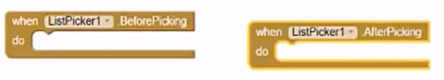

Agregue cliente de Blueetooth

* Click Designer
* Connections

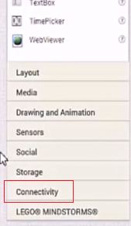

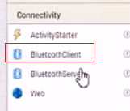

En el ListPikker1

Before Picking (list clients)

If (BluetoothCLient. Available)

Set ListPicker.Elements = BluetoothCLient.AdressesAndNames

After Picking

DO: Call BlueToothClient.Connect with Selection

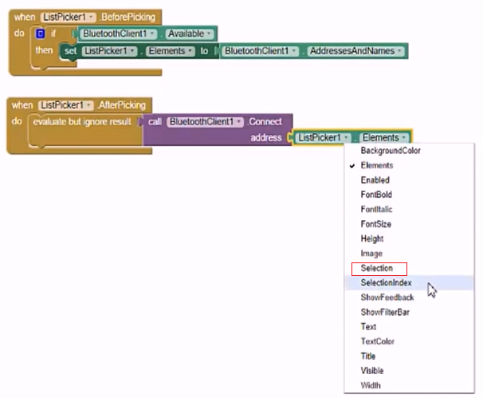

Button1

If (BlueTooth.Client Available) send text “A”

Button2

If (BlueTooth.Client Available) send text “B”

